40KHD

Douglas Gromek

Geoffrey Kitchner

Dragons and Dungeons in the Dark

System Design Document

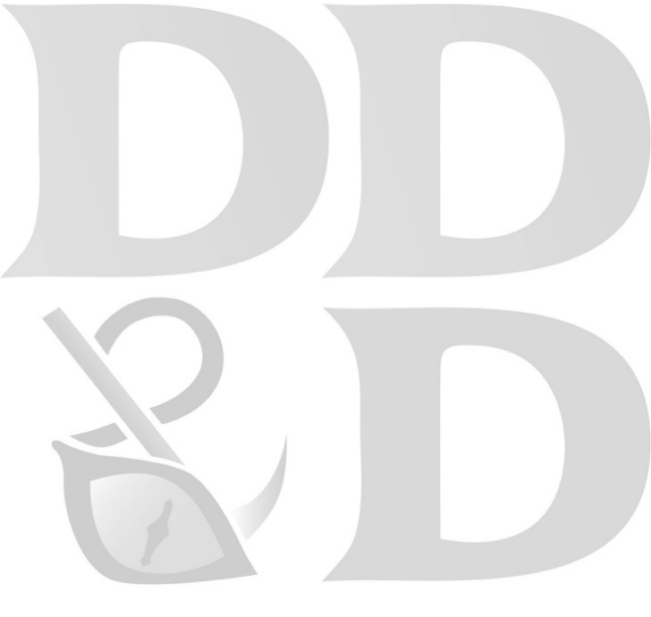

Introduction: (DG)

The purpose of the *System Design Document* is to expand on the models and descriptions provided during the requirements phase of the project. It focuses on a solution to the functions and requirements that the Dragons and Dungeons in the Dark application must accomplish. In the document, the class diagram has been updated to display details that are required for the creation of the application. The attributes now include their data types as well as initial values when relevant. The methods now detail the parameters being used within them, as well as return values. Basic *pseudocode* for every method within the class diagram has been provided. These models will be the templates used by the programmers during the apps’ physical creation. A *state chart* was created for every object of the class diagram. Our application does not have many state changes that occur during its use. However, these diagrams still help convey the transition of our objects from their initial creation through completion. The last section of models, the *first cut domain sequence diagrams* show how the objects within our application interact with all parts of the system. The methods and fields from the class diagram are used to show movement across the automation boundary of the system, interactions with the player, the control class, and the objects themselves.

Design Level Class Diagram: (GK)



**Pseudocode**

**\*See attachement**

Statechart Diagrams: (GK)











First Cut Domain Sequence Diagrams: (DG)

















